[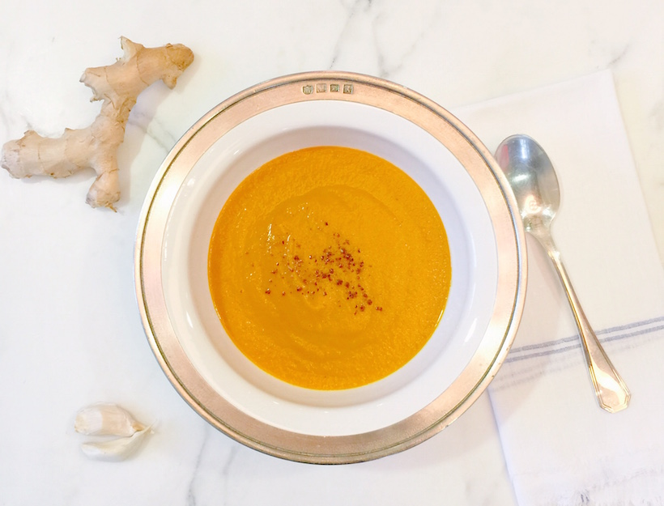](http://goop.com/recipes/roasted-kabocha-soup/)

**TIP**

**If you can’t find kabocha, use butternut squash.**

**ROASTED KABOCHA SOUP**



**GOOP**

*This warming winter soup has a good kick of ginger, which helps stimulate digestion. Use the second half of kabocha in the braised lentil salad.*

**SERVES 3-4**

1 medium kabocha squash, cut in half and seeds removed

2 tablespoons olive oil

2 tablespoons coconut oil

1 large onion, sliced

2 garlic cloves, sliced

2 tablespoons chopped ginger

1 teaspoon ground cumin

½ teaspoon ground coriander

½ teaspoon garam masala

3 cups chicken or vegetable stock

1. Preheat oven to 400°F. Season kabocha halves generously with salt and pepper, drizzle each with 1 tablespoon olive oil, and place flesh side down on a parchment or foil-lined baking sheet. Bake until browned and tender, about 35 minutes.

2. Meanwhile, heat coconut oil in a heavy bottomed saucepan over medium heat. Add sliced onion and a pinch of salt, stir, then turn the heat down to medium low. Cover the pot and cook for about 20 minutes, stirring occasionally, until onions are very soft and sweet.

3. Add the garlic, ginger and ground spices, turn the heat back up to medium high, and sauté for 1 minute. When the spices are fragrant but not burned, add stock, and another big pinch of salt. Partially cover the soup and let it simmer gently until the squash is ready.

4. When the squash is cooked, let it cool slightly, then scrape out the flesh of one half and add it to saucepan. You should have about 2 cups cooked squash. Bring the soup up to a boil, then reduce to a simmer, partially cover, and slowly cook for 10 minutes.

5. Blend, taste for seasoning and enjoy!